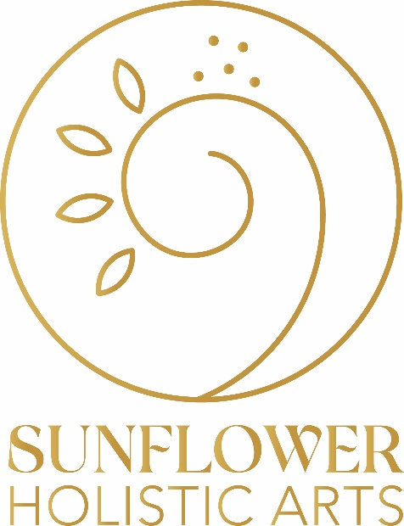
What happens during at Creative Therapy session?
All sessions are client-led and tailored to the goals and needs of the client in the moment. What is shared and created in each session is different, but the structure of each session is the same. The Creative Therapist guides the process by actively listening, asking questions, and by attending to the client in a supportive and compassionate way.
Sessions begin with a brief discussion where the client might share what motivated them to book the session and what they are interested in working on that day or identifying longer term goals for themselves.
Depending on the emotional and physiological needs of the client, the Creative Therapist may lead a guided meditation or full body relaxation to help the client feel more grounded and well-regulated. Sometimes, the client and Creative Therapist begin by playing a game together. Next, the client begins their art making.
Artmaking is entirely within the control of the client. They select the materials they would like to use from the variety that is available to them, including paint, coloured pencils, chalk, clay, plasticine, loose parts, found objects, and natural materials like stones, seashells, and sticks. With these materials, the client can then create a two- or three-dimensional piece. Usually, the client does this work on their own, but the Creative Therapist is always present and accessible.
Once the client determines that their artmaking is complete the Creative Therapist will put it ‘on display’ (ex. taping it to the wall or presenting it on a box) and the client and Creative Therapist will step back and look at the piece together. The Creative Therapist may ask a few questions or ask the client to tell them about what they have created. The Creative Therapist never interprets or judges the work made by a client. The Creative Therapist observes the piece with the client as the client does any interpreting or unpacking of their artwork. The Creative Therapist holds space, listens, asks questions, and guides the client as they find their own understanding from examining their artwork.
The session then closes, and the client either takes their artwork with them or may request to have it broken down and recycled by the Creative Therapist. Often clients will photograph their artwork and then leave it behind.
What do I wear for a session?
This work can get messy. Sometimes clients throw paint directly on a paper taped to a wall! Be prepared to allow yourself to let your creative side be free. Most of the work is done seated at a table, but sometimes the floor is used (if making a large piece like a body outline, for example). Dress comfortably. It can be freeing to wear clothing that is washable and where there is no worry over ruining it with art materials like paint. A smock/apron is available for use if desired.
Who is Creative Therapy for?
Creative Therapy is for everyone. All ages can receive benefits from Creative Therapy. There is no need to have any art experience and no need to have an artistic ability. In fact, being an artist can make Creative Therapy more challenging because it can be harder for an artist to let go of their training and they get stuck in examining their work from a technical standpoint, which is not the point of Creative Therapy. Making art that is pretty, beautiful, or something to put on display is not the objective. Life is messy and making art that reflects the whole facet of human experience is a much more realistic undertaking. Art, like life, can be ugly, disorganized, chaotic, and complicated. The art that is made in Creative Therapy sessions is the outward expression of the inner world. It is unrealistic to want or try to make it look nice because that is not what inner worlds always look like.
Creative Therapy is tactile, immersive, and non-cognitive work. It is a wonderful way for people who are looking for an alternative (or compliment to) talk-therapy, who may struggle with verbalizing their thoughts and feelings, or for people who feel they have “something in them that just needs to come out” and words aren’t quite doing it justice. And sometimes, experiences are too painful to talk about; here talking is not essential. Artmaking does not require the brain to access speech and so clients find they are able to go inward to parts within themselves beyond a conscious level and express these deeply held thoughts, beliefs, feelings, and memories, from an entirely different space. Then through the artmaking process these parts are brought forward, out, and into reality, but all within the control of the client and in a safe environment.
What is Creative Therapy?
Creative Therapy is a holistic arts-based approach to counselling. It is about self-expression, release, restoration, recognizing and changing patterns of behaviour that are unhealthy, and adopting new behaviours that better support happier and more fulfilled lives. In the event of a painful event or life setback, Creative Therapy provides a space and opportunity to help process what has occurred and plan for what is to come next, in a way that feels authentic to the client, realistic, accessible, and more positive. One of the goals of Creative Therapy is for clients to leave each session feeling better than when they arrived.
Why is Creative Therapy beneficial?
Creative Therapy is interested in the wellbeing of the client on all levels: mentally, emotionally, physically, spiritually. If one area is out of balance it will impact the other areas as well. For example, a person living with chronically unmet emotional needs, or has experienced an emotional trauma, is more likely to suffer from depression and have physical ailments like stomach/digestion complaints, headaches, and insomnia. Trying to heal the headache without address the root cause will not be very successful. Creative Therapy primarily uses artmaking as the tool with which to access the inner world. Here is where the answers to healing usually reside. Artmaking helps people go inward, feel into the body, be present, and release or express what has been unsaid or previously inaccessible.
A few of the benefits of Creative Therapy:

- reduced stress
- promotes better sleep
- improved dietary choices
- regulates the nervous system
- step out of fight/flight/freeze/fawn
- improved communication
- increased confidence and self-acceptance
- increased self-awareness
- recognize old patterns of behaviour
- improve and create new behaviours
- improve relationships
- decreased anxiety
- reduced depression
- better management of complex situations
- coping strategies

Where and when can I try Creative Therapy?

Mandy Hollands Ish, B.Ed., M.Ed., dip. HICAT
Creative Therapist
Sunflower Holistic Arts

One day a month on Tuesdays at Saskatoon Naturopathic Medicine:
January 25, February 15, and March 29, 2022
Book directly with Saskatoon Naturopaths by calling: (306) 664-2150

Tuesdays, Wednesdays, and Thursdays at The Veranda
Book directly with Sunflower Holistic Arts on the website: www.sunflowerholisticarts.com

Mondays and Fridays at Mandy’s home studio
Book directly with Mandy by emailing: mandy@sunflowerholsiticarts.com

